Name: Class:

Task 1

- A call centre makes use of computer systems to handle phone calls. Label each of the devices below, then match each one to a likely way that it is used within the call centre.

Device |  | Use in the call centre
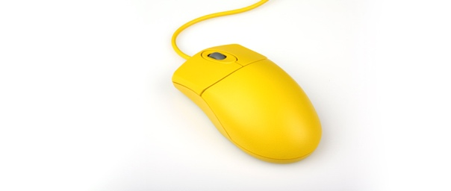
Device name:
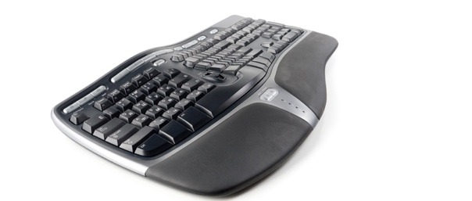
Device name:
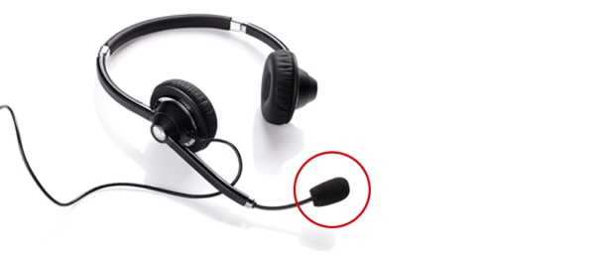
Device name:

Task 2
1. For this task you will need two devices. One device will make use of a real keyboard, whilst the other will need to be a laptop, smartphone or tablet that makes use of a virtual keyboard.
Work in a pair.
One partner should enter the following text using both keyboards. The other partner will record the results in the table below.
Enter the following text using each type of keyboard:
“Virtual keyboards allow users to enter text without the need for physical keys. They make use of a touchscreen to do this. As the screen displays the keys, alternative virtual keyboard views can be selected for characters such as & and #.”
 | Device one – physical keyboard | Device two – virtual keyboard

How long did it take to enter the text?

How many mistakes were made?

How easy was it to type using the keyboard? Think about comfort as well as efficiency and accuracy.
2. Discuss with your partner why different types of input device are used to enter text.

Task 3
Research infra-red touch screens and make notes on your findings. In particular, focus on the following questions:
- What infra-red touch screen products are available?
- How does the technology work in the products you have found?
- Why is it more suitable than using resistive and capacitive?

